25dce049 department of computer engineering

Practical – 2
Semantic HTML5 Pages with Accessibility-Ready Structure
Problem Definition
Develop static HTML5 skeletons for at least 10 StudentHub pages such as Home, About, Register, Login, Dashboard, Events, Profile, Contact, Admin, FAQ, and Feedback. Use semantic tags and an accessibility-friendly structure.
A. Theory
1. What are semantic HTML5 elements?
Answer: Semantic HTML5 elements clearly describe the meaning and purpose of content. Examples include <header>, <nav>, <main>, <section>, <article>, <aside>, and <footer>. They make code easier to understand and help browsers and assistive technologies interpret the page structure.
2. Why should we use <header>, <nav>, <main>, <section>, <article>, <aside>, and <footer> properly?
Answer: <header> contains introductory content or a page/section heading. <nav> groups important navigation links. <main> contains the page's main content and should generally appear once per page. <section> groups related content, usually with a heading. <article> represents a self-contained item, such as an announcement or event card. <aside> contains related or supplementary information. <footer> contains closing information such as copyright or contact links.
3. What is web accessibility?
Answer: Web accessibility means designing webpages so people with different abilities can use them, including people who use screen readers or keyboard navigation. Good headings, meaningful links, form labels, image alternative text, sufficient contrast, and keyboard access improve accessibility.
4. How do labels, headings, alt text, and navigation links improve accessibility?
Answer: A <label> connected to a form control explains what information is required. Headings create a logical content hierarchy. The alt attribute describes meaningful images to users who cannot see them. Links should use clear text such as “View Events” rather than vague text such as “Click here.”
5. How is navigation managed consistently across multiple HTML pages?
25dce049 department of computer engineering

Answer: A common navigation menu can be placed inside <nav> on every page. Each <a> element uses an href pointing to the correct HTML file. Keeping link labels and order consistent helps users understand and move around StudentHub. The current page can be indicated with aria-current="page".
6. What are a skip-to-content link and breadcrumb navigation?
Answer: A skip-to-content link lets keyboard users bypass repeated navigation and jump to the main content. Breadcrumbs show a page's location in the site hierarchy, for example Home > Dashboard > Profile. They make larger websites easier to navigate.
7. What is the purpose of the viewport meta tag and lang attribute?
Answer: The viewport meta tag helps the page fit mobile-device screens. The lang attribute on <html>, such as lang="en", identifies the document language and helps screen readers pronounce text correctly.
8. Why should every HTML page have a unique title and a logical heading structure?
Answer: A meaningful, unique <title> identifies the page in browser tabs and assists users navigating between pages. Headings should follow a logical hierarchy, usually one clear <h1> for the main page topic, followed by <h2> and <h3> as needed.
B. Implementation / Output / Result
Create a project folder named StudentHub. Store the following 11 HTML files in it. The example below shows a reusable semantic page structure. Use the same header, navigation, skip link, main-content landmark, and footer on every page; change the page title and main content.
1. Project folder structure
StudentHub/
├── index.html
├── about.html
├── register.html
├── login.html
├── dashboard.html
├── events.html
├── profile.html
├── contact.html
├── admin.html
├── faq.html
└── feedback.html
2. Common semantic HTML5 template (save as index.html)
<!DOCTYPE html>
<html lang="en">
<head>
<meta charset="UTF-8">
25dce049 department of computer engineering

<meta name="viewport" content="width=device-width, initial-scale=1.0">
<title>StudentHub | Home</title>
</head>
<body>
<a href="#main-content">Skip to main content</a>
<header>
<h1>StudentHub</h1>
<p>Your student information portal</p>
<nav aria-label="Main navigation">
<ul>
<li><a href="index.html" aria-current="page">Home</a></li>
<li><a href="about.html">About</a></li>
<li><a href="register.html">Register</a></li>
<li><a href="login.html">Login</a></li>
<li><a href="dashboard.html">Dashboard</a></li>
<li><a href="events.html">Events</a></li>
<li><a href="profile.html">Profile</a></li>
<li><a href="contact.html">Contact</a></li>
<li><a href="admin.html">Admin</a></li>
<li><a href="faq.html">FAQ</a></li>
<li><a href="feedback.html">Feedback</a></li>
</ul>
</nav>
</header>
<main id="main-content">
<section aria-labelledby="welcome-heading">
<h2 id="welcome-heading">Welcome to StudentHub</h2>
<p>Access announcements, academic information, events, and student services.</p>
<p><a href="events.html">Explore upcoming events</a></p>
</section>
<section aria-labelledby="updates-heading">
<h2 id="updates-heading">Latest Updates</h2>
<article>
<h3>Student Notice</h3>
<p>Check the portal regularly for academic notices and announcements.</p>
</article>
</section>
<aside aria-labelledby="quick-links-heading">
<h2 id="quick-links-heading">Quick Links</h2>
<ul>
<li><a href="dashboard.html">Open Dashboard</a></li>
<li><a href="profile.html">View Profile</a></li>
</ul>
</aside>
</main>
<footer>
<p>&copy; 2026 StudentHub. For student use.</p>
<p><a href="contact.html">Contact support</a></p>
</footer>
</body>
</html>
3. Content plan for the remaining pages
about.html — About StudentHub
Explain the portal's purpose, available student services, and how students can use it.
register.html — Create an Account
Provide labelled fields for full name, email, student ID, and password. Use appropriate input types and required attributes.
login.html — Student Login
Provide labelled email/username and password fields, plus a submit button and a link to registration.
dashboard.html — Student Dashboard
Show a summary of attendance, upcoming assignments, recent notices, and quick links.
events.html — Campus Events
Show event items using <article>, with an event title, date, description, and registration link.
profile.html — Student Profile
Show student details with clear labels and a meaningful image alt attribute if a profile image is used.
contact.html — Contact StudentHub
Show support email/contact information and a labelled contact form.
admin.html — Admin Panel
Show a static outline of user management, event management, and announcements. This HTML page alone does not provide admin security.
faq.html — Frequently Asked Questions
Organize questions and answers in sections or <details>/<summary> elements with accessible text.
feedback.html — Give Feedback
Provide labelled name/email fields, a rating choice, a feedback textarea, and a submit button.
4. Example accessible registration form
<section aria-labelledby="register-heading">
<h2 id="register-heading">Create an Account</h2>
<form action="#" method="post">
<p>
<label for="full-name">Full name</label>
<input id="full-name" name="full_name" type="text" autocomplete="name" required>
</p>
<p>
<label for="email">Email address</label>
<input id="email" name="email" type="email" autocomplete="email" required>
</p>
<p>
<label for="student-id">Student ID</label>
<input id="student-id" name="student_id" type="text" required>
</p>
<p>
<label for="password">Password</label>
<input id="password" name="password" type="password"
autocomplete="new-password" required>
</p>
<button type="submit">Register</button>
</form>
</section>
Note: action="#" is a static demonstration only. A real registration system requires server-side processing and secure validation.
5. Breadcrumb navigation example (intermediate)
<nav aria-label="Breadcrumb">
<ol>
<li><a href="index.html">Home</a></li>
<li><a href="dashboard.html">Dashboard</a></li>
<li aria-current="page">Profile</li>
</ol>
</nav>
6. Implementation steps
1. Open VS Code and create a folder named StudentHub.
2. Create the 11 HTML files listed above.
3. Copy the common template into each file, then update the title, current-page link, and main content.
4. Use semantic elements such as header, nav, main, section, article, aside, and footer where appropriate.
5. Add meaningful form labels, a logical heading hierarchy, useful alt text for meaningful images, and clear link text.
6. Add the skip-to-content link to every page. Add breadcrumbs on pages below Home if using the intermediate extension.
7. Check that every navigation link opens the correct file. Keep file names and href values identical.
8. Open index.html in a browser and test every page and form control using the keyboard.
9. Inspect the pages with browser developer tools or an accessibility checker, and capture screenshots for the report.
C. Evidence of Work (Screenshots)
• Home page opened in browser
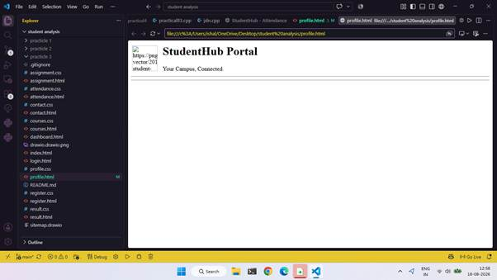

• Register/Login form showing labels
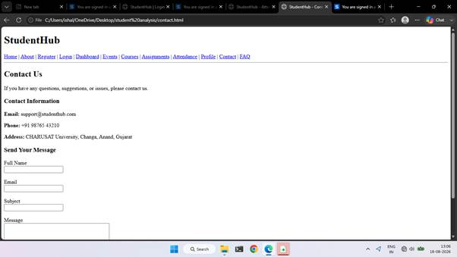
Result.html:
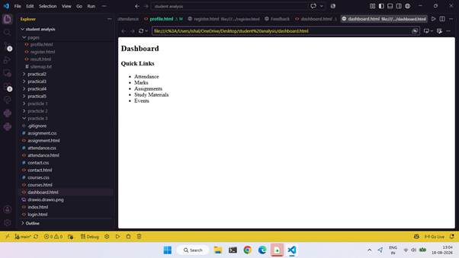
Register.html:
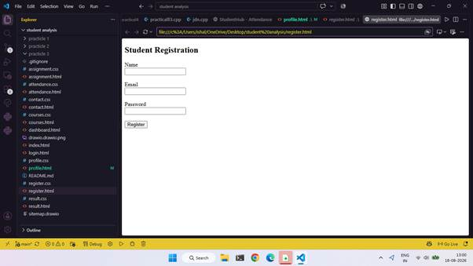
D. Accessibility Checklist
☐ Every page declares <!DOCTYPE html>, lang="en", character encoding, and viewport metadata.
☐ Each page has a meaningful and unique <title>.
☐ Navigation is inside a labelled <nav> and links point to existing files.
☐ Each page has a skip-to-content link and a matching main id.
☐ Main content is wrapped in <main>; landmarks are used appropriately.
☐ Headings follow a logical hierarchy without skipping levels unnecessarily.
☐ Every form field has a programmatically associated <label>.
☐ Meaningful images have useful alt text; decorative images use alt="".
☐ Links have descriptive text and can be reached with the keyboard.
☐ Keyboard focus is visible; no functionality depends only on a mouse.
☐ Breadcrumbs, if included, use a labelled nav and indicate the current page.
☐ All pages were opened and tested in a browser.
E. Challenges Faced
1. Selecting suitable semantic elements for different content sections.
2. Maintaining the same navigation structure across multiple pages.
3. Ensuring that labels, headings, links, and image descriptions support accessibility.
4. Checking that all relative links correctly open the intended HTML files.
F. Learning Outcomes
1. Learned to build static pages using HTML5 semantic elements.
2. Understood basic accessibility practices for headings, forms, images, and navigation.
3. Created a consistent multi-page structure for the StudentHub portal.
4. Practised linking pages and testing navigation using a web browser.
5. Learned how skip links and breadcrumbs improve navigation.
G. Viva Questions
What is semantic HTML?
Answer: HTML that uses elements describing the meaning of their content.
What is the purpose of the <main> element?
Answer: It identifies the dominant content of the page; normally one visible main landmark is used per page.
What is the difference between <section> and <article>?
Answer: <section> groups related content; <article> is a self-contained item that can stand independently.
Why is the alt attribute important?
Answer: It provides a text alternative for meaningful images.
How do you connect a label to an input?
Answer: Use the label's for attribute with the same value as the input's id.
What does aria-label do?
Answer: It provides an accessible name when a visible text label is not available or is insufficient.
What is a skip link?
Answer: A link near the start of the page that lets keyboard users jump to the main content.
What is breadcrumb navigation?
Answer: A trail of links showing the current page's location in the website hierarchy.
Why is lang="en" used?
Answer: It declares the document's primary language to browsers and assistive technology.
Does semantic HTML alone guarantee full accessibility?
Answer: No. It is a foundation; keyboard testing, good labels, contrast, meaningful content, and other checks are also needed.
H. Result
The StudentHub static page structure was planned with semantic HTML5 elements, consistent navigation, accessible form examples, a skip-to-content link, and optional breadcrumb navigation. After creating the pages, verifying links, and completing the checklist, insert screenshots as evidence of the actual work.
Faculty Remarks
(Keep this section blank for faculty.)

